Project Design Phase-II
Data Flow Diagram & User Stories

Date | 19 February 2026
Team ID | LTVIP2026TMIDS24859
Project Name | Calculating Family Expenses using Service  Now
Maximum Marks | 4 Marks

Data Flow Diagrams:
A Data Flow Diagram (DFD) is a traditional visual representation of the information flows within a system. A neat and clear DFD can depict the right amount of the system requirement graphically. It shows how data enters and leaves the system, what changes the information, and where data is stored.

Flow Integration & Dependencies
Sequential Dependencies
- Table Creation and Configuration must be completed before any expense data can be recorded in the system.
- Daily Expense Entry depends on properly configured tables and validated form fields.
- Table Relationships enable linking Daily Expenses with Family Expenses for structured data flow.
- Business Rule Automation relies on accurate daily expense entries and established table relationships.
- Form Configuration and Related Lists depend on completed tables and relationships to display consolidated data.
- Expense Analysis and Consolidated Views require successful execution of business rules and data aggregation..
- Documentation captures the complete development lifecycle, including configuration steps, automation logic, and results.
Data Flow Diagram :
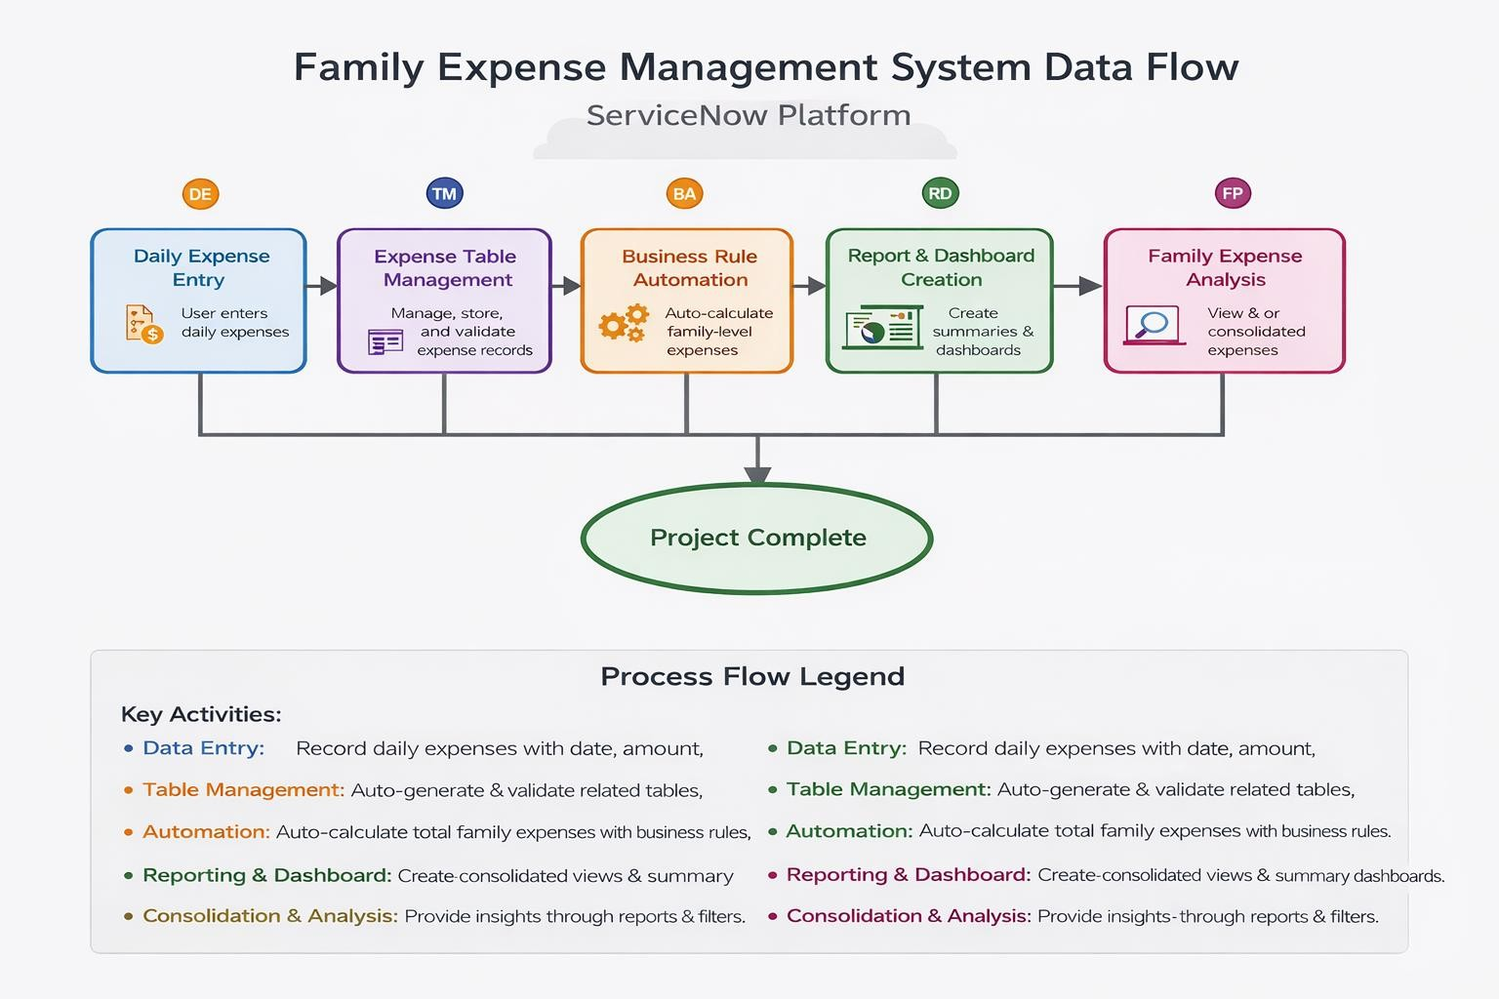

User Stories
Use the below template to list all the user stories for the product.
User Type | Functional  Requirement  (Epic) | User Story  Number | User Story / Task | Acceptance criteria | Priority | Release
System  Administrator | Performance Optimization | USN-1 | As a System Administrator, I want the Family Expense application to perform efficiently with fast form loading and calculations, so that users experience smooth interaction even with large expense data. | Form load time under 5 seconds. Business rule execution completes without delay. | HIGH | Sprint-1
System  Administrator | Data  Configuration &  Overview | USN-2 | As a System Administrator, I want to configure core tables and provide an overview of expense data, so that data integrity and structure are maintained. | Family Expenses and Daily Expenses tables created with correct fields and validations. | High | Sprint-1
Family Head | Expense  Summary  Visualization | USN-3 | As a Family Head, I want to view a consolidated summary of family expenses, so  that I can quickly understand overall spending. | Display total expense amount, date-wise grouping, and consolidated expense details. | High | Sprint-3
Family Member | Daily Expense Entry | USN-4 | As a Family Member, I want to record my daily expenses easily, so that all expenses are accurately tracked. | Daily expense form allows  entry of date, amount, member name, and comments with validations. | Medium | Sprint-2
Family Head | Strategic Expense Insights | USN-5 | As a Family Head, I want to understand spending patterns over time, so that I can make informed budgeting decisions. | Summary view shows expense trends and comparisons across dates. | High | Sprint-1
Expense Manager | Category-wise  Expense Analysis | USN-6 | As an Expense Manager, I want to analyze expenses based on different parameters such as family members and dates, so that I can identify high-spending areas. | Grouped views and related lists display  expense breakdowns clearly. | High | Sprint-3
All Users | Integrated  Dashboard  Experience | USN-7 | As any system user, I want to access all housing market visualizations through a unified, responsive dashboard, so that I can efficiently navigate between different analyses and maintain context. | Single Family Expenses form with related list showing linked Daily Expenses. | High | Sprint-3
User Type | Functional  Requirement  (Epic) | User Story  Number | User Story / Task | Acceptance criteria | Priority | Release
Family Head | Member-wise  Expense  Segmentation | USN-8 | As a Family Head, I want to see how expenses vary by family member, so that I can manage and control individual spending patterns. | Expense details  clearly indicate memberwise contributions. | Medium | Sprint-3
Expense Manager | Daily-to-Family  Expense  Aggregation | USN-9 | As an Expense Manager, I want daily expenses to automatically update family-level totals, so that manual calculations are eliminated. | Business Rule correctly aggregates daily expenses into family expenses on insert/update. | High | Sprint-2
System  Administrator | System  Administration &  Data Governance | USN-10 | As a System Administrator, I want to manage users, roles, and data security, so that the system remains secure, reliable, and wellgoverned. | Role-based access, data integrity, and audit-ready configuration ensured. | High | Sprint-1

